AP Calc AB Name: _______________

______________ _____________

WS Assessment

Target 5:

INTRO TO DIFFERENTIATION

**I can:**

* Determine average rates of change using difference quotients.
* Represent the derivative of a function as the limit of a difference quotient.
* Determine the equation of a line tangent to a curve at a given point

Unit 2: Differentiation: Definition and Fundamental Properties

HW Target 5

Unit 2 Progress Check MCQ Part A

Recall

Suppose a company’s total cost in dollars to produce *x* units of its product is given by

*C*(*x*) = 0.01*x*2 + 25*x+* 1500

Find the average rate of change of total cost for the first 100 units produced

the second 100 produced.

Another common rate of change is velocity. For instance, if we travel 200 miles in our car over a 4-hour period, we know that we averaged 50 mph. However, during that trip there may have been times when we were traveling on an Interstate at faster than 50 mph and times when we were stopped at a traffic light. Thus, for the trip we have not only an **average velocity** but also **instantaneous velocities** (or instantaneous speeds as displayed on the speedometer).

Suppose a ball is thrown straight upward at 64 feet per second from a spot 96 feet above ground level. The equation that describes the height *y* of the ball after *x* seconds is

y = f(x) = 96 + 64x – 16x2 Fill in the table of average velocity

|  |  |  |  |  |  |  |
| --- | --- | --- | --- | --- | --- | --- |
| Time (seconds) | | | Height (ft) | | | Avg. Velocity (ft / sec) |
| Begin | End | Change | Begin | End | Change |  |
| 1 | 2 | 1 | 144 | 160 | 15 | 16 / 1 = 16 |
| 1 | 1.5 | 0.5 |  |  |  |  |
| 1 | 1.1 | 0.1 |  |  |  |  |
| 1 | 1.001 | 0.01 |  |  |  |  |

Find the average velocity from x = 1 to x = 1 + h, then find the instantaneous velocity at x = 1

Find derivative by definition

|  |  |
| --- | --- |
|  | Find derivative of f(x) = x3, then f ' (3) |

Given $f(x)=\sqrt{x}$, find the derivative f ' (4) $f\left(x\right)=\frac{x++1}{x-1}$ find derivative f ' (2)

Find derivative by formula

* **If f(x) = xn then $\frac{d}{dx}$ f (x) = f '(x) = nxn-1 NEVER**
* **If f(x) = g(x) ± h(x) then $\frac{d}{dx}$ f (x) = f '(x) = g '(x) ± h '(x) FORGET**
* **If f(x) = kg(x) then $\frac{d}{dx}$ f (x) = f '(x) = k g'(x) THESE**
* **If f(x) = C (a constant number) then $\frac{d}{dx}$ f (x) = f '(x) = 0 FORMULA**

Find the following derivative

|  |  |  |
| --- | --- | --- |
| x5 | 5x7 – 11x3 + 12x – 47 | 4.773 |
|  |  | x4/3 |
| x-3 + 2 |  | x1/2 |
|  |  | (3x - 4)2 |
| t4 – 6y2 | 3x5 - 2t + 7 | 3x5 - 2t + 7 |

Recall: Instantaneous rate of change = **slope of tangent line m**

= **f ' (a) derivative of the function f at the point a** (= $\lim_{x→a}\frac{f(x)-f(a)}{(x-a)}$)

Tell whether f(x) is increasing or decreasing at x = c. and how fast is the change?

Hint: The slope f '(c) is positive or negative?

f(x) = x ½ + 2x – 13, c = 4 f(x) = x -2 – 3x + 11, c = 1

f(x) = x1.5 – 6x + 30, c = 9 f(x) = $-3\sqrt{x}+x+1$, c = 2

Given y = f(x) = 3x2 + 2x + 11 find the derivative of *f* (*x*) at any point (*x*, *f* (*x*)); the slope of the curve at (1, 16); the equation of the line tangent to f9x) at (1, 16)

Find the point on the graph f(t) = t3 – 2t + 4 where the tangent line is horizontal

Does the curve y = x4 – 2x2 + 2 have any horizontal tangents? If so, where?

How about the curve 0.2x4 – 9.7x3 – 2x2 + 5 + 4?

Given f '(x) = 3x2 – 10x + 5, find the “original” function f(x). Hint: Reverse problem

Find the intersection between the function and its derivative and write it in (x, y) format.

REMEMBER IN CALCULUS, ALWAYS WRITE WITH 3 DECIMAL PLACE

a. f(x) = $\frac{x^{3}}{3}-x^{2}-3x+5$ b. g(x) = $\frac{x^{3}}{3}-{2x}^{2}+3x+9$

|  |  |
| --- | --- |
|  | *Differentiability*  *(How f '(a) might fail to exist)*  ***Theorem: If f has a derivative***  ***at x = a, then f is continuous***  ***at x = a***  *The converse of this Theorem is not always true yet.*  *How does a function does not have derivative?* |

*Obviously, if function does not have a limit at the point, then it won't have slope (or derivative).*

*How about continuous? Do research about it and write it here.*

Let $f\left(x\right)=\left\{\begin{matrix}\frac{1-cos⁡(4x)}{x^{2}}, if x<0 \\ a , if x=0 \\ \frac{\sqrt{x}}{\sqrt{16+\sqrt{x}}-4}, if x>0\end{matrix}\right.$ for what vale of a, f is continuous at x = 0

Examine the differentiability of the function f defined by

$$f\left(x\right)=\left\{\begin{matrix}2x +3, if-3≤x<-2 \\ x+1 , if-2≤x<0 \\ x+2, if 0≤x≤1 \end{matrix}\right.$$

Relationships between the Graphs of f and f '

The graph of f(x) is given below, sketch the graph of f '(x)

Algebraically

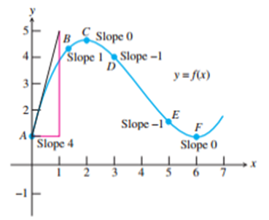 f(x) = ax3 + bx2 + cx + d.

Find f(x) and f ’(x)

Assessment

Compute the derivative using limit definition

f(x) = x2 f(x) = x-2

Find the slope of y = f(x) = x2 at the point A(2, 4) both by definition and by formula

Let $f\left(x\right)=\left\{\begin{matrix}\frac{sin⁡(x)}{x}+\cos\left(x\right), if x≠0 \\ k , if x=0\end{matrix}\right.$ for what vale of k, f is continuous at x = 0

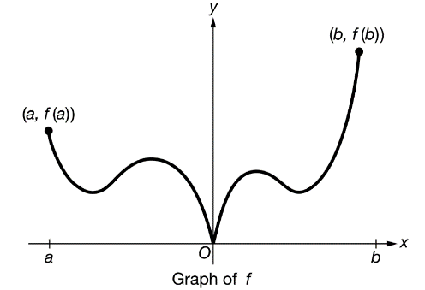The graph of a function f with f(b)>f(a) is shown above for a≤x≤b. The derivative of f exists for all x in the interval a<x<b except x=0. For how many values of c, for a<c<b, does $\lim_{x→c}{\frac{f\left(x\right)-f(c)}{x-c}}=\frac{f\left(b\right)-f(a)}{b-a}$

Sketch

Let f be the function given by f(x) = x3  – 2x2 − 4x What values of x, at which does the line tangent to the graph of f have the smallest slope?